876741 Awais Afridi

Q1: An economy is in long-run macroeconomic equilibrium when each of the following aggregate demand shock occurs. What kind of gap-inflationary o recessionary- will the economy face after the shock, and what type of fiscal policies would help move the economy back to potential output? How would your recommended [fiscal policy](https://moodle.unive.it/mod/resource/view.php?id=41308) shift the aggregate [demand curve](https://moodle.unive.it/mod/resource/view.php?id=38952)?

a. A stock market boom increases the value of stocks held by households.

b. Firms come to believe that a recession in the near future is likely.

c. Anticipating the possibility of war, the government increases its purchases of military equipment.

d. The quantity of money in the economy declines and interest rates increase.

*Note: Expansionary fiscal policies: Such policies include increasing government purchases of goods and services, increasing government transfers, and reducing taxes.*

*Contractionary fiscal policies: Such policies include reducing government purchases of goods and services, lowering government transfers, and raising taxes.*

1. As the stock market booms and the value of stocks held by households increases, there will be an increase in consumer spending; this will shift the aggregate demand curve to the right. The economy will face an inflationary gap. Policy makers could use contractionary fiscal policies to move the economy back to potential output. This would shift the aggregate demand curve to the left.
2. If firms become concerned about a recession in the near future, they will decrease investment spending and aggregate demand will shift to the left. The economy will face a recessionary gap. Policy makers could use expansionary fiscal policies to move the economy back to potential output. This would shift the aggregate demand curve to the right.
3. If the government increases its purchases of military equipment, the aggregate demand curve will shift to the right. The economy will face an inflationary gap. Policy makers could use contractionary fiscal policies to move the economy back to potential output. The government would need to reduce its purchases of non-defense goods and services, raise taxes, or reduce transfers. This would shift the aggregate demand curve to the left.
4. As interest rates rise, investment spending will decrease and the aggregate demand curve will shift to the left. The economy will face a recessionary gap. Policy makers could use expansionary fiscal policies to move the economy back to potential output. This would shift the aggregate demand curve to the right.

----------------------x--------------------------x-------------------------------x--------------------------x----------------------------

Q2: In this question we try to understand why stagflation is particularly hard to fix using [fiscal policy](https://moodle.unive.it/mod/resource/view.php?id=41308).

Assume that the economy is facing the situation described by the following figure:

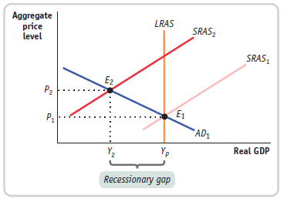

a) What would be the appropriate [fiscal policy](https://moodle.unive.it/mod/resource/view.php?id=41308) response to this situation if the primary concern of the government was to maintain economic growth? Illustrate the effect of the policy on the equilibrium point and the aggregate price level using the diagram.

b) What would be the appropriate [fiscal policy](https://moodle.unive.it/mod/resource/view.php?id=41308) response to this situation if the primary concern of the government was to maintain price stability? Illustrate the effect of the policy on the equilibrium point and the aggregate price level using the diagram.

c) Discuss the effectiveness of the policies in parts a and b in fighting stagflation.

1. The government needs to apply expansionary fiscal policies, increase government spending and *reduces taxes* – which will move the aggregate demand curve back to the right, increasing the output up to optimum output level (Yp) but the new prices will increase because of the reason that unemployment will decreases and disposable income will increase – which will result in high prices of goods – and the intended results of economic growth will be obtain as more goods will be sold at high prices and high amount of money will circulate in the economy – also amount of the marginal propensity to save will get reduced – as in case of high prices people cannot save much money. (but high inflation rate is in fact a problem for a country of low economic growth or high percentage of people below poverty line)

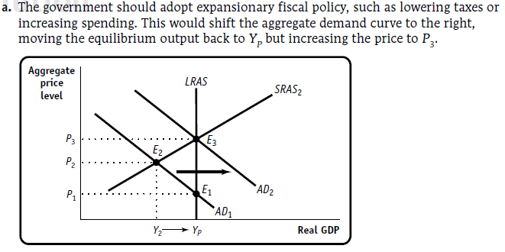

1. The government in this case needs to adopt contractionary fiscal policy, decrease government spending and *increase taxes –* which will move the aggregate demand curve further to the left but downwards (further reduction in price levels and also in output) – the recessionary gap will increase more – the economy will fall in more crisis because of the less trade in market – filled inventories (positive) – less money circulation in the country – decreased production by firms or even decrease in number of new firms – high unemployment – less disposable income – and other related problems will occur.

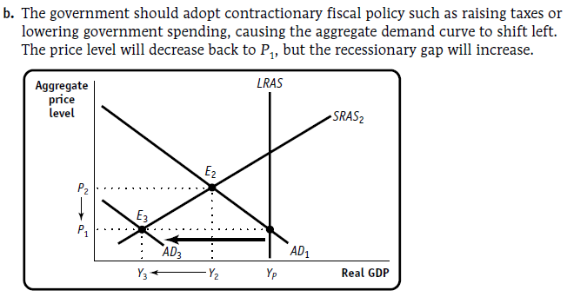

1. Although expansionary fiscal policy can help bring aggregate output back to potential output, it also raises the aggregate price level. This makes the problem of inflation worse in a situation where low economic growth is coupled with higher-than-desired inflation. Contractionary fiscal policy—reduced government purchases of goods and services, an increase in taxes, or a reduction in government transfers—can help bring down the price level. However, contractionary fiscal policy will further increase the recessionary gap.

---------------x-----------------------x--------------------------x------------------------x--------------------------x-----------------

Extra my point of view: Maybe the best strategy for the government would be to adopt expansionary fiscal policy coupled with increase in subsidies level instead of reducing tax level.

This policy, though would increase government spending and will reduce the unemployment rate but increase inflation.

On the other hand if the government increase subsidies the price level for the general public will reduced while the firms will get their interested/intended profit and the Equilibrium point will fall downward on the optimum output level point.

The shift in total will be right wards first (by applying expansionary policy)

And then downwards along the Yp (by increasing subsidies)